

**Semester Two Examination 2020**

**Question/Answer Booklet**

**PHYSICAL EDUCATION**

**STUDIES UNITS 1 & 2**

Student Name: _____________________________________

Teacher’s Name: _____________________________________

Time allowed for this paper

Reading time before commencing work: Ten minutes

Working time: Two and a half hours

**Materials required/recommended for this paper**

***To be provided by the supervisor***

This Question/Answer booklet

Multiple-choice answer sheet

***To be provided by the candidate***

Standard items: pens (blue/black preferred), pencils (including coloured), sharpener,

correction fluid/tape, eraser, ruler, highlighters

Special Items: non-programmable calculators approved for use in this examination

Important note to candidates

No other items may be taken into the examination room. It is your responsibility to ensure that you do not have any unauthorised material. If you have any unauthorised material with you, hand it to the supervisor before reading any further.

**Structure of this paper**

|  |  |  |  |  |
| --- | --- | --- | --- | --- |
| Section | Number of questions available | Number of questions to be answered | Suggested working time  (minutes) | Marks available |
| Section One  Multiple-choice | 20 | 20 | 30 | 20 |
| Section Two  Short answer | 8 | 8 | 70 | 60 |
| Section Three  Extended answer | 4 | 3 | 50 | 45 |

125

**Total**

# Instructions to candidates

1. The rules for the conduct of this exam have been outlined. Sitting this examination implies that you agree to abide by these rules.
2. Write your answers in the Question/Answer booklet preferably using a blue/black pen. Do not use erasable or gel pens.
3. Answer all questions according to the following instructions.

Section One: Answer **all** questions on the separate Multiple-choice Answer Sheet

provided. For each question shade the box to indicate your answer.

Use only a blue or black pen to shade the boxes. If you make a

mistake, place a cross through that square, then shade your new

answer. Do not erase or use correction fluid/tape. Marks will not be

deducted for incorrect answers. No mark will be given if more than one

answer is completed for any reason.

Section Two: Write answers to in this Question/Answer Booklet. Wherever possible, confine your answers to the line spaces provided

Section Three: Consists of four questions. You must answer two questions. Write

your answers in this Question/Answer booklet.

1. You must be careful to confine your responses to the specific questions asked and to follow any instructions that are specific to a particular question.
2. Supplementary pages for planning/continuing your answers to questions are provided at the end of this Question/Answer booklet. If you use these pages to continue an answer, indicate at the original answer where the answer is continued, i.e. give the page number.

**Section One: Multiple Choice (20 marks)**

This section has **twenty (20)** questions. Answer **all** questions on the separate Multiple-choice answer sheet provided. For each question, shade the box to indicate your answer. Use only a blue or black pen to shade the boxes. If you make a mistake, place a cross through that square, then shade your new answer. Do not erase or use correction fluid/tape. Marks will not be deducted for incorrect answers. No marks will be given if more than one answer is completed for any question.

Suggested working time: 30 minutes.

1. During energy system interplay:

(a) all three energy systems contribute to ATP production however, at any stage, one of them is the main contributor.

(b) all three energy systems supply energy continuously.

(c) the two anaerobic energy systems have been exhausted and most energy is derived from the aerobic energy system.

(d) all three energy systems work sequentially.

2. Feedback about the outcome of a performance such as seeing your time for a 100-metre running sprint is known as:

(a) knowledge of outcome

(b) knowledge of performance

(c) knowledge of results

(d) knowledge of success

3. In which of the following examples is Newton’s third law most evident?

(a) Rowing a boat

(b) Performing a handstand

(c) Applying spin to a soccer ball

(d) Giving with the ball when catching a cricket ball

4. Which of the following options correctly identifies the structures of the heart?

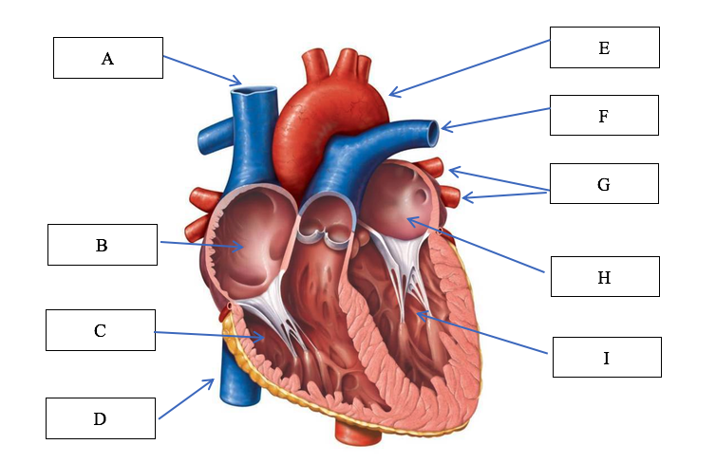

(a) A: Vena cava, B: right atrium, C: right ventricle, E: aorta, F: pulmonary vein: left atrium, G: pulmonary artery

(b) A: Vena cava, B: right atrium, C: right ventricle, E: aorta, F: pulmonary artery,

G: pulmonary vein

(c) B: left atrium, C: left ventricle, D: vena cava, E: aorta, H: right atrium, I: right ventricle

(d) B: left ventricle, C: left atrium, D: vena cava, E: aorta, H: right ventricle, I: right atrium

5. When a learner decides on or develops a motor program based on information input, they are likely to be in which stage of the information processing model?

(a) Identification of stimuli/input

(b) Response identification/decision making

(c) Response/output

(d) Feedback

6. During a submaximal continuous activity (70% max HR) lasting 90 minutes, the majority of the ATP is resynthesised by breaking down:

(a) fats

(b) creatine phosphate

(c) protein

(d) carbohydrates

7. A muscle directly involved in causing a segment to move is called the

(a) agonist

(b) antagonist

(c) stabiliser

(d) controller

8. Positive self-talk techniques are most commonly used during performance or competition. When self-belief is low, athletes are more likely to engage in negative self-talk, however when performance is high, they are more likely to use positive self-talk. What role does positive self-talk play in improving performance?

(a) To remind the athlete of outcome goals they are hoping to achieve

(b) To reset the athlete’s emotions

(c) To increase the athlete’s self confidence

(d) To distract the athlete from negative thoughts reaching their mind

9. Fartlek training:

(a) include predetermined work:rest ratios

(b) should be overloaded by completing an increased distance in a slower time

(c) must include regular rest periods to restore phosphate creatine levels

(d) combines continuous activity with short bursts of intense work at irregular intervals

10. A softball player has two bats, one of which is 300 grams heavier than the other. If the player swings both bats at the same velocity, the heavier bat will be able to produce greater ________ than the lighter bat.

(a) acceleration

(b) momentum

(c) force

(d) torque

11. Diving off a swimming block is an example of:

(a) a discrete motor skill

(b) a serial motor skill

(c) a continuous motor skill

(d) an open motor skill

12. The arteriovenous oxygen (a-vO2) difference:

(a) plateau's when VO2 max is reached

(b) decreases in response to increased exercise loads

(c) increases in response to increased exercise loads

(d) is only fuelled by the aerobic energy system

13. Jackie is about to play her first Women’s AFL game following an ACL knee injury. She is feeling nervous about kicking the ball because she's afraid she might reinjure her knee. Which of the following techniques would be useful for Jackie before the game?

(a) Practicing mental imagery

(b) Using strategies to increase her arousal levels

(c) Using strategies to decrease her arousal levels

(d) Deep centred breathing

14. Two athletes, standing side by side, weigh the exact same amount. Athlete A is 1.80m while Athlete B is 1.65m. Based on this, Athlete A will have a:

(a) improved base of support

(b) higher centre of gravity

(c) lower centre of gravity

(d) higher amount of inertia

15. In preparation for major sporting events, coaches will often implement variety into their training programs in order to try and mitigate reduced motivation in athletes. Which of the following training principles need to be closely considered when introducing variety?

(a) Progressive overload

(b) Intensity

(c) Duration

(d) Specificity

16. Why might an athlete fluctuate between the associative and autonomous stage of learning?

(a) They don't fluctuate between the two stages, they can only be in one stage

(b) They fail to listen to feedback their coach is giving them

(c) They lose self-confidence and therefore move back to the associate stage

(d) As they learn new skills, they need to practice them to become autonomous

17. If an athlete’s final velocity is less than their initial velocity, their acceleration must be:

(a) zero

(b) negative

(c) positive

(d) unknown

18. In training, an athlete completes the following training activity

**Sprint 100m**

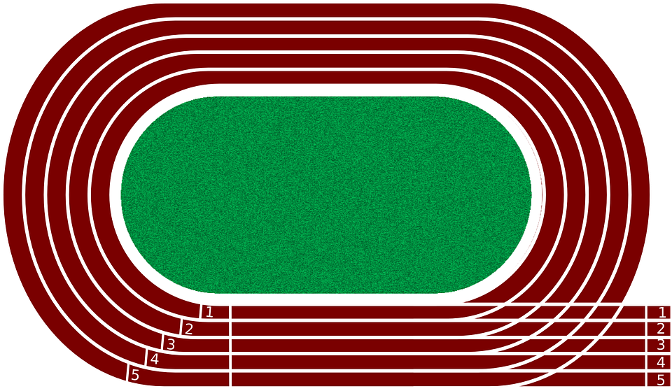

**Walk 100m (recovery)**

**Walk 100m (recovery)**

**Sprint 100m**

What type of training does this activity represent?

(a) Aerobic fartlek

(b) Aerobic interval

(c) Anaerobic fartlek

(d) Anaerobic interval

19. An elite level tennis player who analyses the stance, grip, service position and ball toss of their opponent is utilising which type of cue/cues to improve performance?

(a) Visual

(b) Verbal

(c) Proprioceptive

(d) All of the above

20. The muscle responsible for opposing movements to the prime mover muscle are called:

(a) agonist

(b) antagonist

(c) synergist

(d) reciprocal inhibition

**End of Section One**

**Section Two: Short answer (60 marks)**

This section has **eight (8)** questions. Answer **all** questions. Write your answers in the spaces provided. Use a blue or black pen (**not** pencil) for this section.

Supplementary pages for the use of planning/continuing your answer to a question have been provided at the end of this Question/Answer booklet. If you use these pages to continue an answer, indicate at the original answer where the answer is continued, i.e. give the page number.

Suggested working time: 70 minutes.

________________________________________________________________________

**Question 21 (6 marks)**

An athlete performs eight repetitions of 200 m as part of a training session. Each repetition is performed in 30 sec and is followed by 90 sec of active recovery and 3 minutes of rest between each repetition.

(a) What is the name of the training method described above?

(1 mark)

(b) What is the major energy system being trained?

(1 mark)

(c) What is the major energy source fuelling each repeat sprint

(1 mark)

(d) Describe the principle of progressive overload and identify two (2) ways it could be applied to the training program outlined above.

(3 marks)

**Question 22 (6 marks)**

Task complexity influences optimal arousal levels for individuals. Tasks which are considered ‘hard or complex’ – i.e. require large amounts of information processing or movement precision vs tasks which are considered ‘easy or simple’ – i.e. require small amounts of information processing and involve gross motor movements.

Using the axis below, draw a graph that compares the optimal levels of arousal for the following activities. Label the axis as part of your response.

i) 1RM Dead lift

ii) Bowling a cricket ball

iii) Netball goal shot

iv) Rugby tackle

**Question 23 (10 marks)**

Jack is ten-years-old and is performing a side foot pass in soccer towards a stationary target. His technique is sometimes loose, inconsistent and displays lots of errors.

(a) What stage of learning do you believe Jack is in?

(1 mark)

(b) Explain whether Jack would be aware of what is wrong and if he would know how to fix the problem.

(2 marks)

(c) For Jack to progress to the next stage of learning, feedback plays a pivotal role. Discuss the type of feedback Jack will need and how this may change as he moves to the next stage of learning.

(4 marks)

(d) Part of skill development involves the performer improving their ability to execute the given skill in a constantly changing environment. Describe two (2) activities a coach could implement to make the skill of kicking a soccer ball more open.

(2 marks)

**Question 24 (4 marks)**

One of the major functions of the circulatory system is the circulation of blood around the body. During exercise, blood flow redistributes to the working muscles so that 80-90% of total Cardiac Output is directed to them.

(a) Using your knowledge of blood vessels, explain how the body achieves this.

(2 marks)

(b) Another major function of the circulatory system is to maintain body temperature. Using your knowledge of blood vessels, explain how the body redirects blood flow in hot conditions to help manage this.

(2 marks)

**Question 25 (9 marks)**

The following question relates to the image below of a triple jumper.

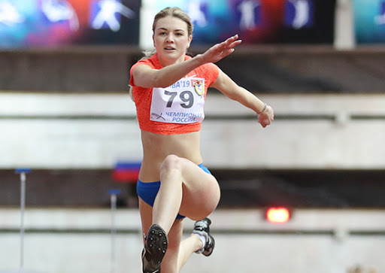

(a) Identify the three (3) articulating bones that make up the elbow joint.

(3 marks)

(b) Identify the movement taking place at the athlete’s left elbow joint.

(1 mark)

(c) Identify the agonist and antagonist muscles responsible for the movement in (b).

(2 marks)

(d) Identify the articulating bones that make up the hip joint.

(2 marks)

(e) Identify the movement taking place at the athlete’s right hip joint.

(1 mark)

**Question 26 (6 marks)**

The following table represents a weights program for an athlete to improve their muscular strength.

Exercise Sets Repetitions Resistance

|  |  |  |  |
| --- | --- | --- | --- |
| Exercise | Sets | Repetitions | Resistance |
| Squats | 3 | 6 | 8RM |
| Bench press | 3 | 2 | 4RM |
| Dead lifts | 3 | 15 | 40%RM |
| Military press | 3 | 4 | 4RM |
| Lat pull downs | 4 | 4 | 4RM |
| Leg extension | 4 | 4 | 50%RM |

(a) To achieve improvements in muscular strength, how many times per week would the athlete need to undertake the above weights training schedule?

(1 mark)

(b) In the table, what does 4RM stand for/represent?

(1 mark)

(c) Do any prescriptions of sets, repetitions and resistance seem inappropriate to the stated goal of muscular strength improvement? Justify your answer.

(3 marks)

(d) In a three-month program consisting of the exercises from the table, indicate when overload should be applied.

(1 mark)

**Question 27 (13 marks)**

The spin/rotation method has taken over from the glide as the preferred putting technique for shot-putters. It is believed to be the best method to enable the putter to maximise their distance.

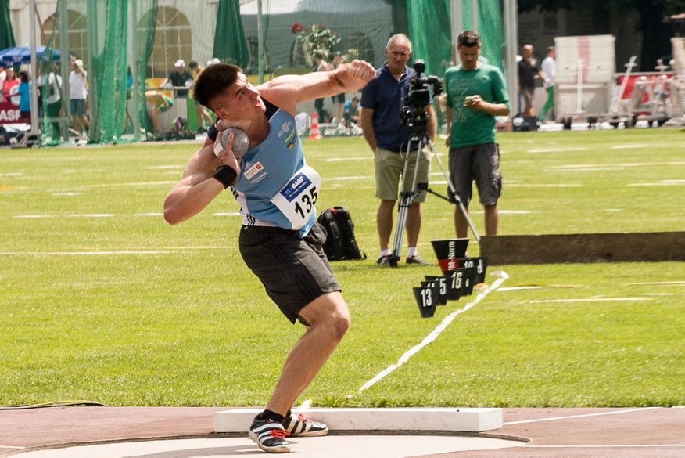

(a) Define each of Newton’s Laws and provide an example of how they apply to the shot put.

(6 marks)

(b) One analyst watching the event writes the following comment:

‘A direct linear relationship exists between the angle of release and the distance travelled for any given speed of release.’

Do you agree with this comment? Justify your response.

(2 marks)

(c) Segmental interaction is a key biomechanical principle which allows for performance in the shot put to be maximised. Using the space below, draw a graph to show how the legs, torso and arms interact to build momentum and produce optimal performance.

(4 marks)

**Question 28 (8 marks)**

Nideffer’s Model of Attention determined that different sports have varying attentional requirements and viewed attentional focus along two dimensions – direction and width.

Below is a diagrammatic representation of Nideffer’s Model of Attention. Complete the diagram by labelling the axis (A-D) and describing the attentional requirements of each quadrant (1-4).

A

2.

1.

B

D

4.

3.

C

**End of Section Two**

**Section Three: Extended answers (45 marks)**

This section contains **four (4)** questions. You must answer **three (3)** questions. Write your answer in the spaces provided.

Supplementary pages for the use of planning/continuing your answer to a question have been provided at the end of this Question/Answer booklet. If you use these pages to continue an answer, indicate at the original answer where the answer is continued, i.e. give the page number.

Suggested working time: 50 minutes.

**Question 29 (15 marks)**

The ‘Tailwind Nutrition 3 Marathons in 3 Days’ is an annual event held in far North Queensland in which a marathon is run each day over three consecutive days. Competitors can opt to compete in only one or two of the marathons, but the ‘Grand Slam’ medal goes only to those who complete all three marathons.

(a) Describe the nutritional requirements for an athlete trying to complete the ‘Grand Slam’ event. Include in your response considerations before, during and after each marathon.

(9 marks)

(b) An individual’s concentration can be influenced by age, skill level and activity type. Describe how each of these factors impact concentration and for each factor, suggest one strategy the coach could use to help improve their concentration.

(6 marks)

**Question 30 (15 marks)**

To maximise performance, a performer needs to be able to interpret and understand both internal and external cues. The use of cues starts in the cognitive stage of learning and continue as athletes progress to the autonomous stage.

(a) Discuss three (3) types of cues available to an athlete and explain how they can be used throughout the different stages of learning.

(9 marks)

(b) In swimming, athletes adopt a position on the starting blocks which enable them to accelerate quickly.

i) Using your understanding of balance and stability, describe how a swimmer manipulates their position on the starting block to enable rapid entry into the water.

ii) Identify the points of a 100m swimming race where a swimmer would be experiencing three different types of acceleration.

(6 marks)

**Question 31 (15 marks)**

In 2019, one of AFL football’s most talked about kicks was immortalised in a bronze statue outside Melbourne’s Federation Square.

The statue captures AFLW player Tayla Harris kicking a goal during a match against the Western Bulldogs. It was designed based on a similar photo to the one pictured above and demonstrates how Tayla generates great power in her kick.

(a) Describe the principle of segmental interaction and outline five (5) characteristics that Tayla applies to generate the most force when kicking the football.

(7 marks)

(b) The action of breathing in and out is innervated by changes to the comparative pressure between the thorax (internal pressure) and the atmosphere (external pressure).

Explain the mechanics of inspiration and expiration. In your answer, refer to the muscles involved in this process.

(8 marks)

**Question 32 (15 marks)**

After three months of isolation and very little physical activity following the Covid-19 outbreak, a friend invites you to start playing ultimate frisbee in their summer league team. The team trains three times a week with each session lasting 90 minutes and involving a range of aerobic based training activities.

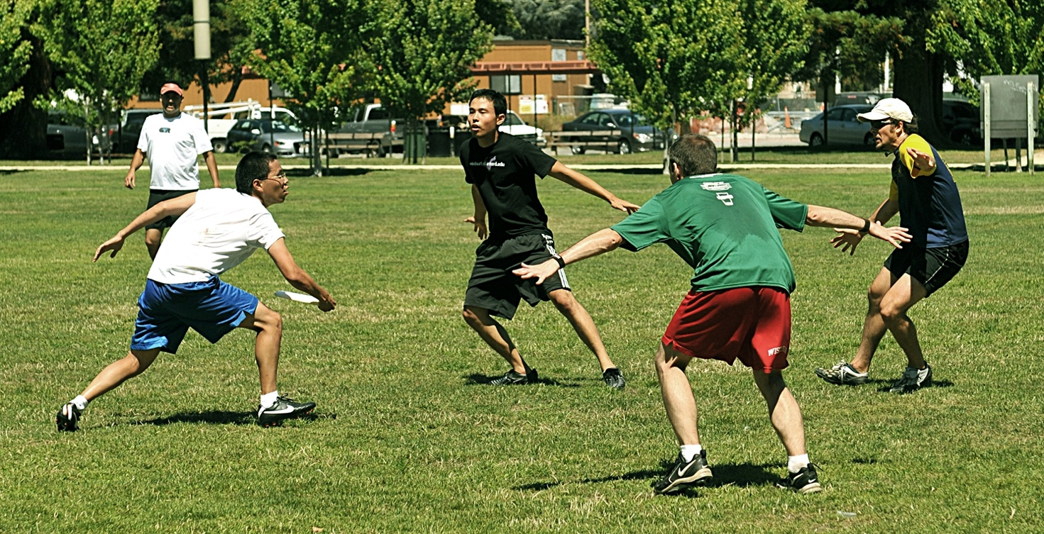

Explain three (3)immediate circulatory responses to physical activity that you would experience during a training session. Furthermore, discuss how the heart rate, ventilation rate and the stroke volume change following a 12-week training program and explain the contribution that each of these adaptations has on improving the athlete’s aerobic capacity.

**End of Section Three**

Supplementary page

Question number:___________

Supplementary page

Question number:___________

_____